Chapter 4

How to Retrieve Data From Two or More Tables

Exercises
Unless otherwise stated, use the explicit join syntax.
1. Write a SELECT statement that returns all columns from the Vendors table inner-joined with the Invoices table.
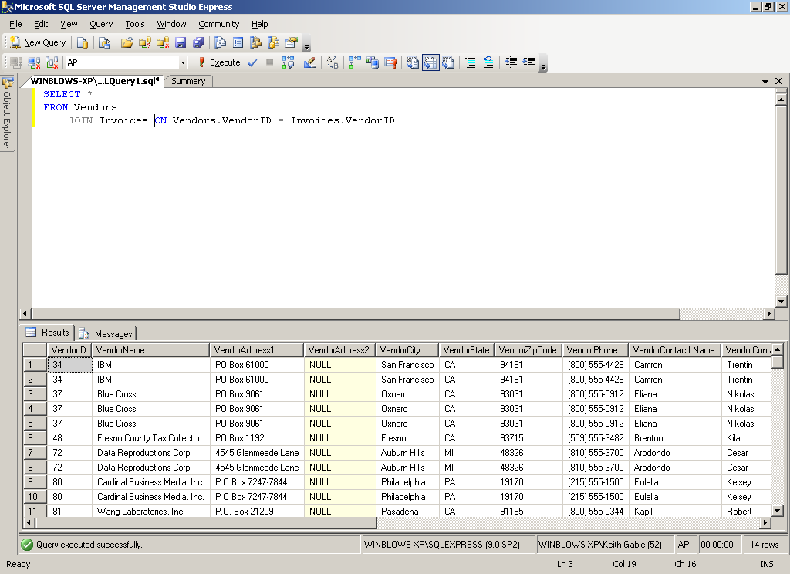
2. Write a SELECT statement that returns four columns:
VendorName From the Vendors table
InvoiceNumber From the Invoices table
InvoiceDate From the Invoices table
Balance InvoiceTotal minus the sum of PaymentTotal and CreditTotal
The result set should have one row for each invoice with a non-zero balance. Sort the result set by VendorName in ascending order.
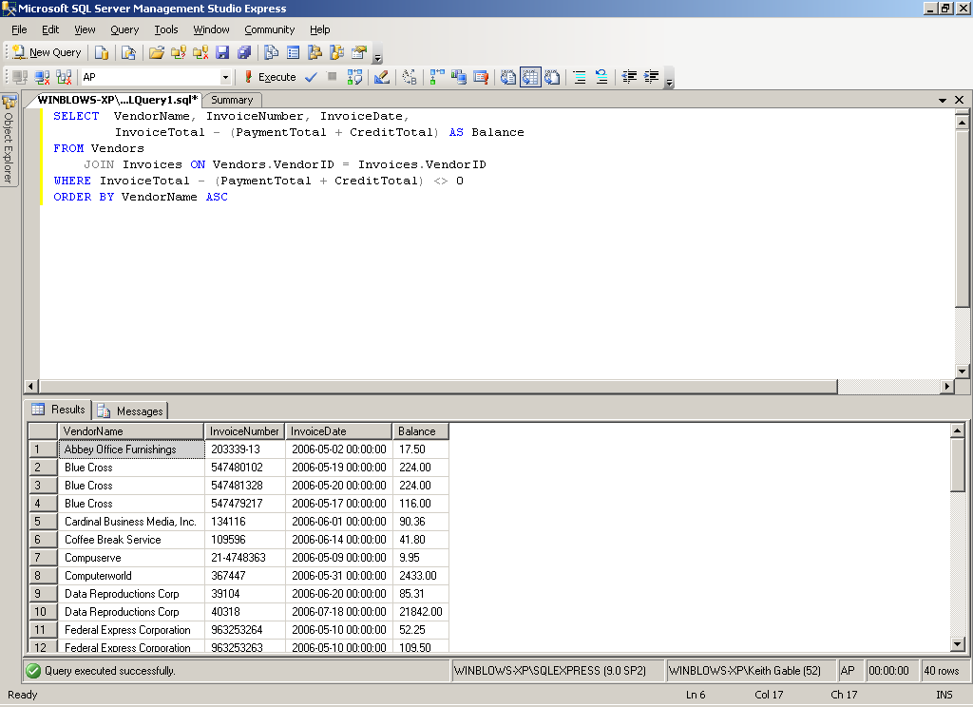

3. Write a SELECT statement that returns three columns:
VendorName From the Vendors table
DefaultAccountNo From the Vendors table
AccountDescription From the GLAccounts table
The result set should have one row for each vendor, with the account number and account description for that vendor’s default account number. Sort the result set by AccountDescription, then by VendorName.
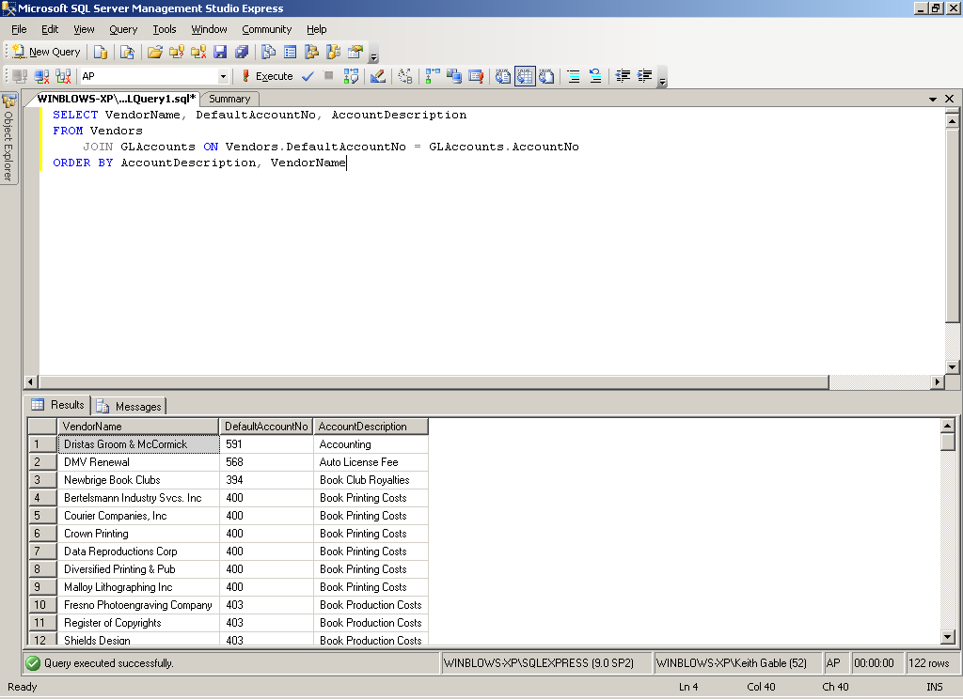

4. Generate the same result set described in exercise 2, but use the implicit join syntax.
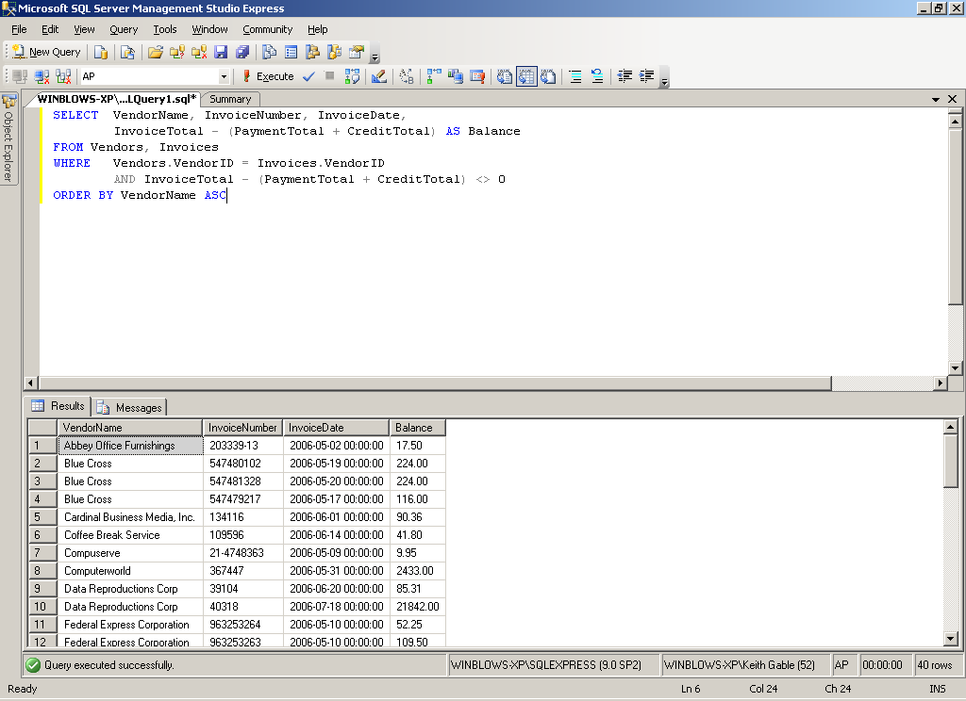
5. Write a SELECT statement that returns five columns from three tables, all using column aliases:
Vendor VendorName column
Date InvoiceDate column
Number InvoiceNumber column
# InvoiceSequence column
LineItem InvoiceLineItemAmount column
Assign the following correlation names to the tables:
Vend Vendors table
Inv Invoices table
LineItem InvoiceLineItems table
Sort the final result set by Vendor, Date, Number, and #.
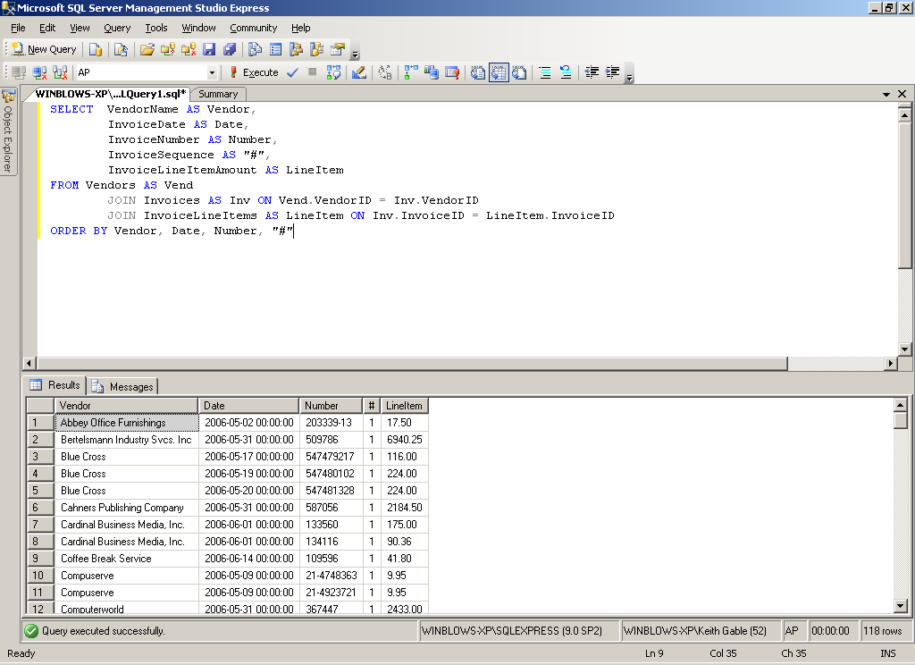
6. Write a SELECT statement that returns three columns:
VendorID From the Vendors table
VendorName From the Vendors table
Name A concatenation of VendorContactFName and VendorContactLName, with a space in between
The result set should have one row for each vendor whose contact has the same first name as another vendor’s contact. Sort the final result set by Name.
Hint: Use a self-join.
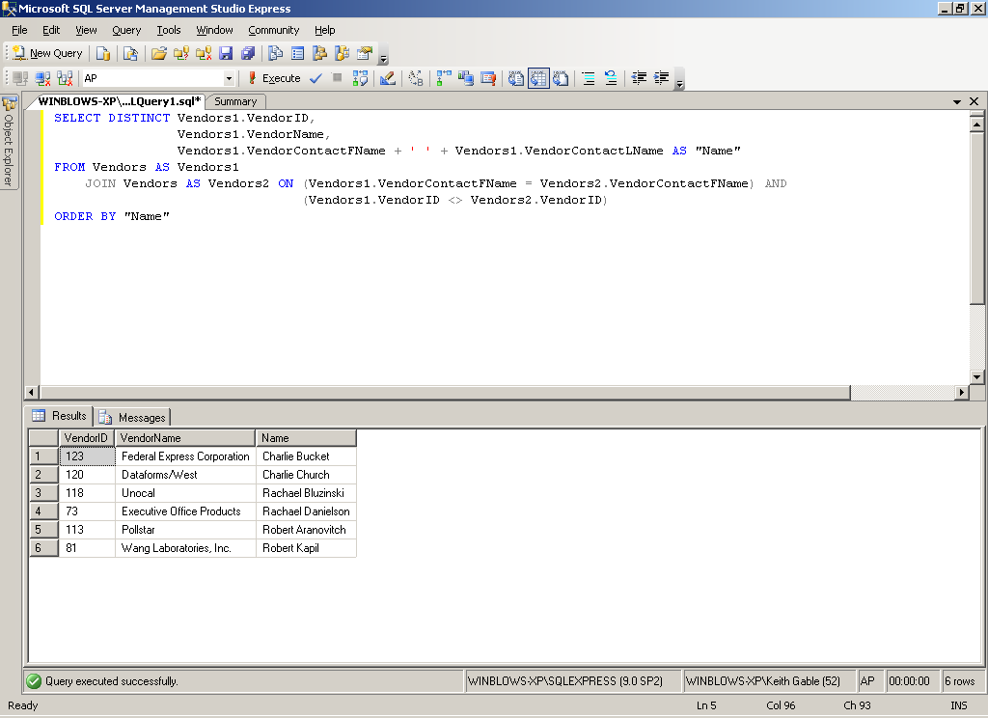
7. Write a SELECT statement that returns two columns from the GLAccounts table: AccountNo and AccountDescription. The result set should have one row for each account number that has never been used. Sort the final result set by AccountNo.
Hint: Use an outer join to the InvoiceLineItems table.
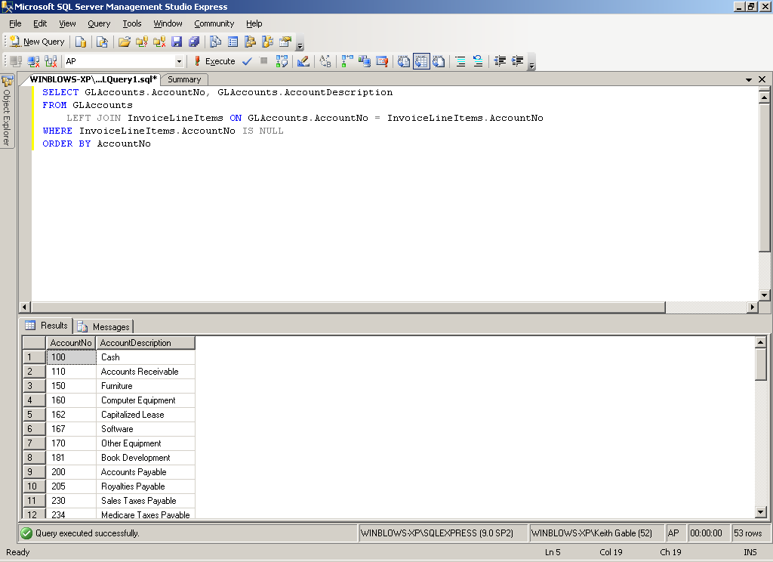

8. Use the UNION operator to generate a result set consisting of two columns from the Vendors table: VendorName and VendorState. If the vendor is in California, the VendorState value should be “CA”; otherwise, the VendorState value should be “Outside CA.” Sort the final result set by VendorName.
